Tina Sherwell

658 words

**Shawa, Laila (b. 1940)**

Laila Shawa was born in Gaza in 1940. Between 1957-1958, she travelled to Cairo to study art at the Leonardo da Vinci Art Institute. She then pursued her studies in Fine Arts in Rome at the Accademia San Giacomo, University of Rome, receiving her BA in 1960. In her summers, she would travel to participate in the School of Seeing, studying under the famous expressionist artist Oscar Kokoschka in Salzburg, Austria. After the 1967 war, she moved to Beirut, which was a cultural hub for many Palestinians, where she lived and worked until 1975. Thereafter she lived between Gaza and the UK up until 1988 and thereafter in the UK. Shawa’s work spans different media: painting, photography, printing, sculpture and video works, offering socio-political critiques of her subject matter that predominantly relates to the Palestinian and Middle East contexts over the decades. Her series ‘Women and the Veil’ of late 1980s, explored the contractions inherent in practices of Arab society, particularly, critiquing consumerism and blind faith in doctrines. She critiques these contexts through playfulness and satire, such as in *The Impossible Dream* (1988). While in her series of paintings, *The Hands of Fa*tima, she explored the practices of magic in Arab societies. The paintings dissolve perspectival space into a kaleidoscope of colors, patterns and rituals.

*The Walls of Gaza* (1994) series saw a shift in medium as Shawa used photographs taken on a visit home to Gaza during the intifada as the main impetus for the series. These photographs were printed on canvas, combined with silk-screen techniques. The works engaged with the layers of graffiti focusing on the textual and textural quality and the traces and transformation of the urban landscape of Gaza. Her next series *Children of War, Children of Peace*, (2006) deployed similar techniques, focusing on the plight of children, using methods of repetition and bright colors characteristic of pop art through which she points to the vulnerability of the child, and the absurdity of stereotyping children as a threat in contexts of conflict, but who in reality remain a traumatised generation in the aftermath of war. The graffiti in the background is by rival groups and is rendered illegible, in which the cacophony of slogans cancel each other out.

There is continuity in Shawa’s works where she often draws on the methodologies and techniques of pop art, with bright colors, striking messages and contradictory images and forms. In *The Other Side of Paradise* (2012) series she explored the delicate question of female suicide bombers, through video work and canvases, in particular the erotisation and weaponisation of the female body. In her series *Disposable Bodies*, (2011) where “she created a series of headless, armless, feetless mannequins in bold colors, adorned in gemstones belts, which a on closer observation explore the redundancy of women suicide bombers.” In series of paintings, such as *Cast Lead*, Shawa recalls Persian miniatures but refers to the bombardment of Gaza and the use of drones in the war on Palestinians. She comments, “Growing up in the Middle East, where many diverse cultures live in close proximity, I learned to speak several different languages. Speaking different languages helps one understand how complex problems give rise to multiple explanations that are often mutually exclusive. From the privileged vantage point of the artist, I try to consider all sides of any question. Through my multi-layered approach, I express the dichotomies, ironies, and hypocrisies to which others seem less attuned.”

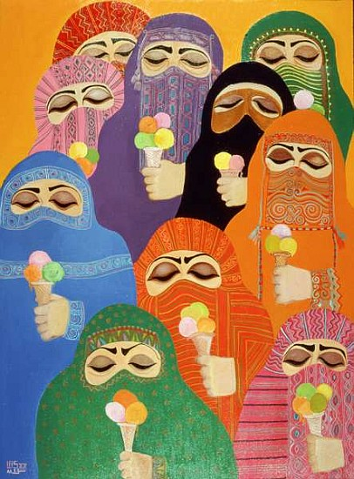

**Laila Shawa, *Impossible Dream*, 1988.**

<http://www.octobergallery.co.uk/artists/shawa/>.

**References and further Reading**

Mikdadi-Nashashibi Salwa, ed. (1994) *Forces of Change, Artists of the Arab Worl*d, Washington D.C., USA.

Author? (1997) *Artistes Palestiniens Contemporains*, Institute Du Monde Arabe, Paris, France.  
  
Porter, Venetia, ed. (2006, 2008) *The Word into Art,* The British Museum*,*.*Sarab* , DIFC, Dubai..

*Impossible Dream*s, *the work and Art of Laila Shawa* (2009) Skira Books, Milano.

Monem, Nadine (2009) *Contemporary Art in The Middle East*, Art World, Black Dog Publishing, London..

Shawa, Laila (1994) *Works 1965- 1994,* AI-Hani Books.

<http://www.britishmuseum.org/explore/online_tours/museum_and_exhibition/word_into_art/laila_shawa_palestine-uk,_ch.aspx>

<http://muslima.imow.org/content/political-personal>

<https://www.frieze.com/shows/review/laila-shawa/>

<http://signsjournal.org/laila-shawa/>

<http://www.therecessionists.co.uk/middle-eastern/laila-shawa>